**Title**

Enhanced security and blockchain based online meeting platform.

**Field of Invention**

The field of innovation lies in **Computer Science**, specifically in the subdomains of **web development, blockchain technology, and secure communication systems**. This solution integrates advanced technologies like end-to-end encryption, decentralized storage, smart contracts, and real-time communication to create a scalable, secure, and privacy-focused online meeting platform.

**Background**

Traditional online meeting platforms relied on centralized servers with basic password protection and limited encryption. They lacked features like secure role-based access or tamper-proof logs, leaving sensitive information vulnerable to breaches, tampering, and unauthorized access. These systems were unsuitable for industries needing high confidentiality.

Modern platforms offer end-to-end encryption, multi-factor authentication, and limited privacy features. However, their reliance on centralized servers leaves them exposed to breaches and data loss. Tamper-proof records and decentralized storage are missing, and tools like secure role-based access and immutable activity logs remain underdeveloped, creating gaps for high-security users.

Our platform integrates blockchain for tamper-proof logs, decentralized storage for secure data, and blockchain-based identity verification for enhanced authentication. It includes encrypted communication, role-based access, and collaboration tools like real-time chat and voting. Scalable and user-friendly, it meets diverse needs while prioritizing security and transparency.

**Objectives of the Invention**

The objective is to create a secure online meeting platform using blockchain as well as enhanced security protocol and technologies for privacy and safety. It will record meeting activities in a way that can’t be changed, ensuring trust. All communication, like video and files, will be encrypted. The system will use secure logins and store data safely in a decentralized way, making it easy to scale and adapt to different needs.  
  
The system will include interactive features like voting through polls, allowing participants to make decisions collectively during meetings. Polls can be created instantly, enabling users to vote on various topics or questions in real time, making discussions more dynamic and inclusive. Additionally, the platform will support real-time chat, providing a space for participants to share thoughts, ask questions, or discuss ideas without interrupting the ongoing meeting. These features enhance collaboration and ensure active engagement among all attendees.

Online Meeting Workflow**

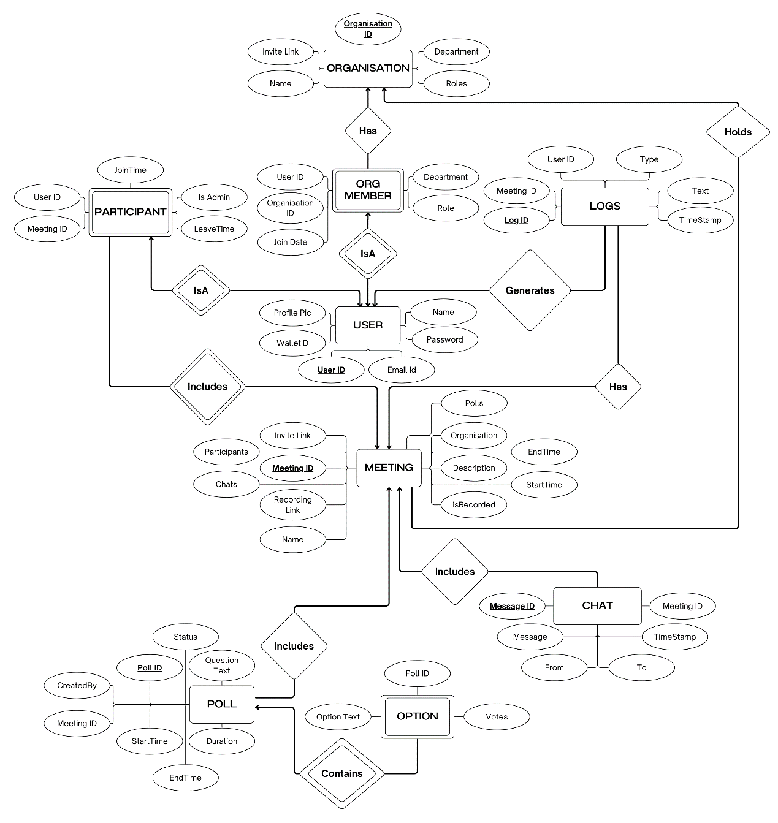

**ER Diagram**

**Claims**

1. **Unmatched Security:** Use of SRTP (Secure Real-Time Transport Protocol) for encrypting real-time media and WebRTC for peer-to-peer communication, ensuring end-to-end encryption. Blockchain-based identity verification through Solana secures user authentication and protects meeting data from unauthorized access.

2. **Immutable Records:** Every meeting action is logged using Solana’s blockchain, providing an immutable audit trail. This ensures complete transparency, preventing tampering or unauthorized alterations to meeting records.

3. **Seamless User Authentication:** Integration of Google OAuth 2.0 for secure, frictionless login, combined with role-based access control via Solana blockchain for secure management of meeting privileges, allowing only authorized users to access sensitive content.

4. **Scalable Infrastructure:** Built on Node.js for real-time processing, the platform leverages MongoDB for flexible data management and scales efficiently to support a growing user base without compromising performance.

5. **Decentralized Storage:** IPFS is used to securely store meeting data, ensuring decentralized, distributed storage that maintains data integrity and guards against unauthorized access or loss.

6. **Adaptable Across Industries:** The platform’s flexible architecture allows customization to suit diverse sectors such as healthcare, legal, education, and government, enabling tailored solutions for each industry’s unique needs.

7. **User-Friendly Interface:** Designed with ease of use in mind, the platform offers an intuitive, responsive interface that caters to both tech-savvy and non-technical users, ensuring a seamless meeting experience.

**Technology Used**

* **Frontend:** The frontend leverages **JavaScript** **(ES6)** for implementing logic, handling events, and making API calls, enabling dynamic content updates and interactive features. **React.js (v18.x)** serves as the core framework for building the user interface, offering a component-based architecture that promotes reusability, maintainability, and efficient state management. For blockchain interactions, **Anchor** **(v0.25.x)** is used to seamlessly interact with the Solana blockchain, enabling operations such as viewing meeting logs and verifying data integrity through a convenient abstraction layer. Additionally, **Google OAuth 2.0** is integrated to provide secure user authentication via Google accounts, offering a trusted and seamless login experience while reducing the need to manage user credentials directly.
* **Backend:** The backend uses **Node.js (v20.x)** as the runtime environment for server-side code, leveraging its event-driven, non-blocking I/O model for efficiently handling API requests, business logic, and integrations in real-time applications. Data is stored in **MongoDB** **(v6.x)**, a flexible document-based database that supports schema evolution, with **Mongoose** providing a schema-based interface for type casting, validation, query building, and hooks. For logging, **Morgan** **(v7.x)** tracks HTTP requests for debugging and performance monitoring, while **Winston** **(v3.x)** manages application-level logging with customizable formats and outputs. The backend framework, **Express** **(v4.x)**, is used to build RESTful API endpoints and middleware, offering scalability and robust features for web application development.
* **Blockchain:** The project integrates **Solana** **(v1.x)** to store immutable records of meeting logs, ensuring enhanced security and transparency through its high-performance blockchain, which offers fast transaction speeds and low fees. **Web3.js** **(v1.x)** facilitates seamless interaction with the Solana blockchain from the Node.js backend, providing tools for account management, transaction handling, and smart contract execution. **Rust** **(v1.x)** powers the decentralized logic for operations such as access control and meeting verification, leveraging its performance and safety features to ensure reliable and secure smart contracts. For larger files like meeting recordings or shared documents, **IPFS** **(v0.21.x)** is used, offering decentralized, content-addressed storage for data integrity and efficient distribution.
* **APIs:** The system integrates the **Google Calendar API** **(v3.x)** to enable users to schedule meetings and sync them with their personal Google Calendars, providing bi-directional synchronization to ensure AICTE meetings are always updated. For advanced scheduling, the **Calendly API** **(v2.x)** is used, offering seamless meeting time selection, support for complex availability rules, time zone conversions, and automated reminders. Additionally, the **Google Text-to-Speech API** **(v1beta1)** enhances accessibility by providing real-time transcription of meetings, making content searchable and inclusive. With support for multiple languages and voices, it ensures a versatile and user-friendly experience for diverse audiences.

# **Real-Time Communication:** The system utilizes **WebRTC (v1.x)** for peer-to-peer audio, video, and data communication directly between browsers, reducing server load and latency for seamless real-time interactions during online meetings. To ensure the security of these communications, **SRTP** **(v2.x)** is employed to protect the confidentiality and integrity of transmitted audio and video streams. Additionally, **WebSocket** (via Socket.io) **(v4.x)** enables real-time, bidirectional communication between clients and the server, supporting features like instant messaging, live updates, and collaborative tools, enhancing the platform's functionality and responsiveness during meetings.

**Hardware**

The platform operates on cloud servers, which securely store all meeting-related data, including user details, meeting logs, and shared files, in cloud databases. This ensures high availability, reliable performance, and easy access from anywhere. The cloud infrastructure also allows the system to scale smoothly as the number of users grows.

**End-User Devices**

The platform supports modern browsers such as Chrome, Firefox, Safari, and Edge, ensuring compatibility across laptops, desktops, smartphones, and tablets. This versatility allows users to access the platform seamlessly on their preferred devices, facilitating secure and convenient participation in online meetings from anywhere.

**Environment**

The platform is entirely browser-based, supporting cross-platform access on Windows, macOS, Android, and iOS. This allows both individuals and businesses to find online-meeting options easily, regardless of their operating system.

**Abstract**

This decentralized online meeting platform integrates blockchain technology, real-time communication, and advanced security protocols to ensure privacy, transparency, and scalability. It offers features like end-to-end encrypted video, audio, and file sharing, along with role-based access control through blockchain-based identity verification. Immutable meeting logs stored on the Solana blockchain enhance accountability, while decentralized storage via IPFS secures sensitive data. The platform also supports real-time chat, voting through polls, and interactive tools for seamless collaboration. Built using React, Node.js, WebRTC, and MongoDB, it is adaptable across industries and provides a user-friendly interface for secure, efficient, and inclusive online meetings.

**End Users**

End users for this decentralized online meeting platform could include businesses, educational institutions, government organizations, and individuals who prioritize security and privacy. Companies conducting sensitive meetings, schools offering online classes, and government bodies holding confidential discussions would benefit from the platform's secure features. Additionally, remote teams, legal professionals, healthcare providers, and any group handling private data or needing secure communication channels can use this platform to ensure safe, transparent, and encrypted interactions. The platform is adaptable to various industries needing trustworthy and scalable online communication solutions.

**Advantages**

1. **Enhanced Security:** Use of enhanced security protocols and technologies like SRTP to ensure secure communication and protect sensitive data during meetings.

2. **Transparency and Accountability:** Immutable logging of meeting activities ensures full transparency and accountability, preventing tampering or manipulation of records.

3. **User Control and Authentication:** Role-based access control and blockchain-based identity verification provide secure, customized access for different users.

4. **Scalable and Adaptable:** Can easily scale to accommodate growing user bases and is adaptable to various industries like education, healthcare, and business.

5. **Decentralized Storage:** Essential Meeting data is stored securely on decentralized platforms, ensuring data integrity, and preventing loss or unauthorized access.

**Conclusion**

The system is designed to provide a secure and efficient platform for online meetings by integrating advanced technologies like blockchain, decentralized storage, and real-time communication. It offers a complete solution for institutions, organizations, and individuals to communicate effectively while ensuring high standards of security and privacy.

At the core of the system, blockchain technology ensures that data remains immutable and transparent. This means that every activity, such as scheduling or access to resources, is securely recorded and cannot be tampered with. Additionally, blockchain-based identity verification ensures that only authorized users can join meetings, providing a robust authentication process.

To protect meeting data, the system uses decentralized storage solutions like IPFS. This eliminates the risks of unauthorized access or data loss, as files are securely distributed across the network. Real-time communication is powered by WebRTC, allowing smooth audio and video conferencing with end-to-end encryption. This ensures that all conversations remain private and secure.

The platform includes essential tools for effective collaboration, such as meeting scheduling, file sharing, and role-based access control. Role-based access ensures that participants can only access features and resources based on their assigned roles, enhancing security and usability. Additional functionalities like voting systems, chat, transcription, and screen sharing further improve engagement and productivity during meetings.

The system is user-friendly and scalable, making it suitable for a wide range of users, from small teams to large organizations. Its backend infrastructure handles user accounts, meeting functionalities, and logs, while the frontend uses modern technologies to provide a seamless and intuitive experience. Integration with public APIs for scheduling and reminders ensures convenience for users, helping them stay organized.

Overall, this online meeting platform combines the strengths of decentralized and real-time technologies to offer a secure, scalable, and feature-rich solution. It not only safeguards data integrity and privacy but also makes meetings more efficient and collaborative. By addressing modern communication needs with a focus on security, transparency, and usability, the system sets a new standard for secure online communication and collaboration.